Franklin Install

Create a new instance

(made in public for now – can move to private subnet later if required)

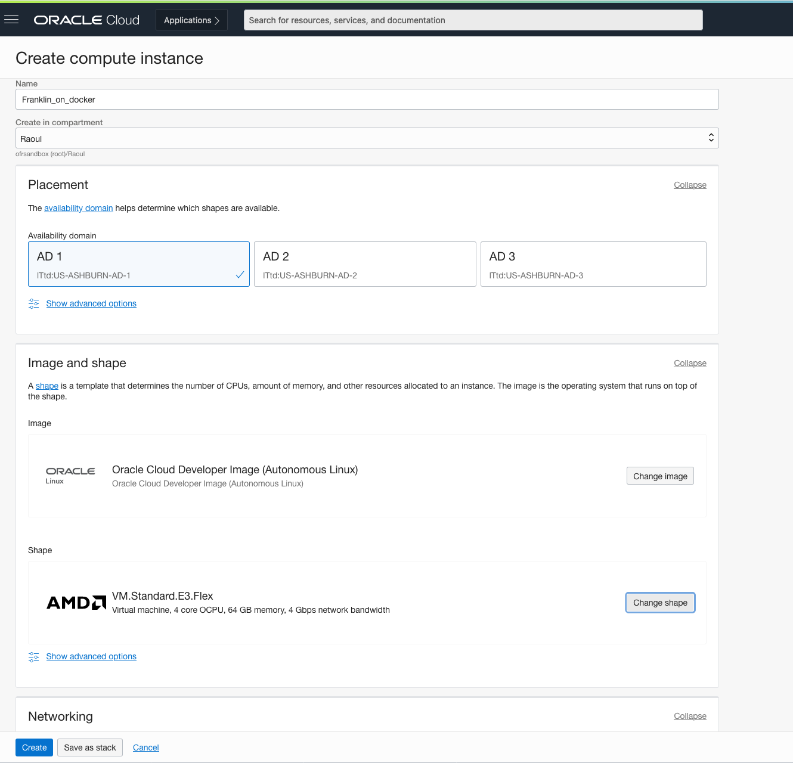

Assign to existing public subnet

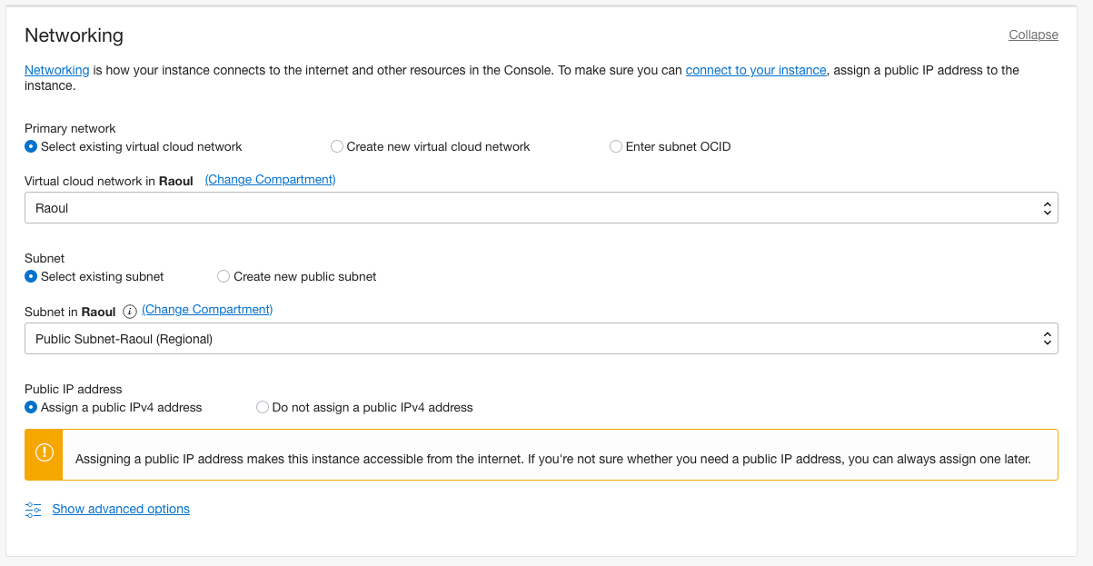

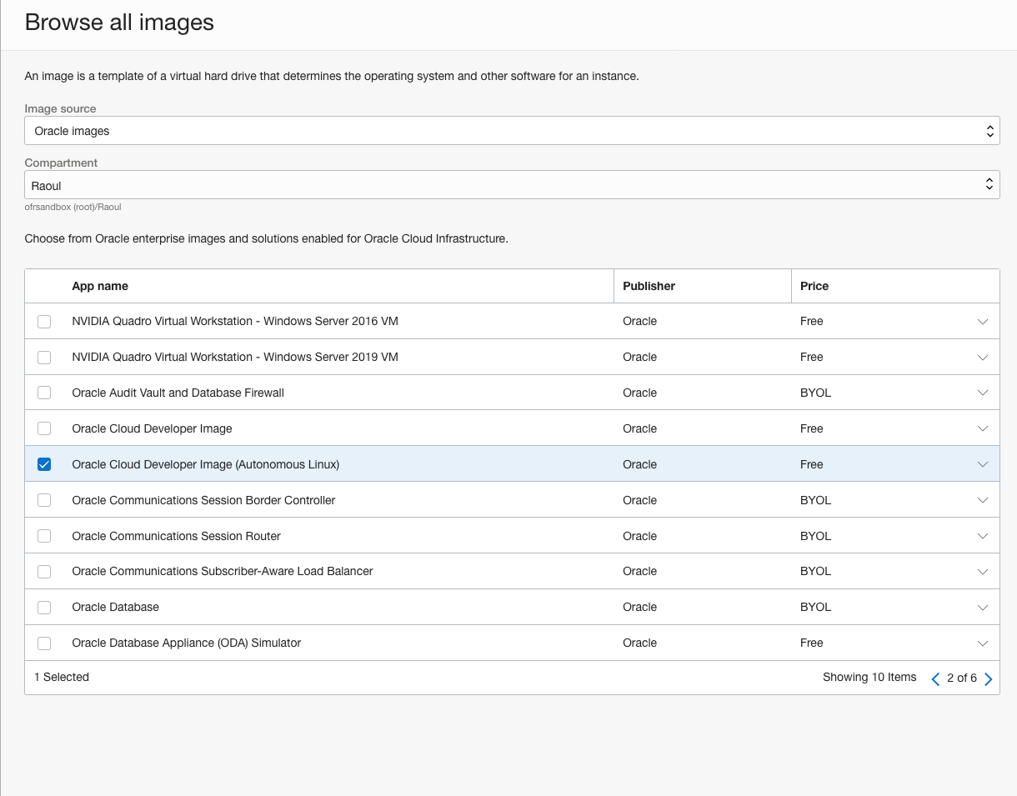

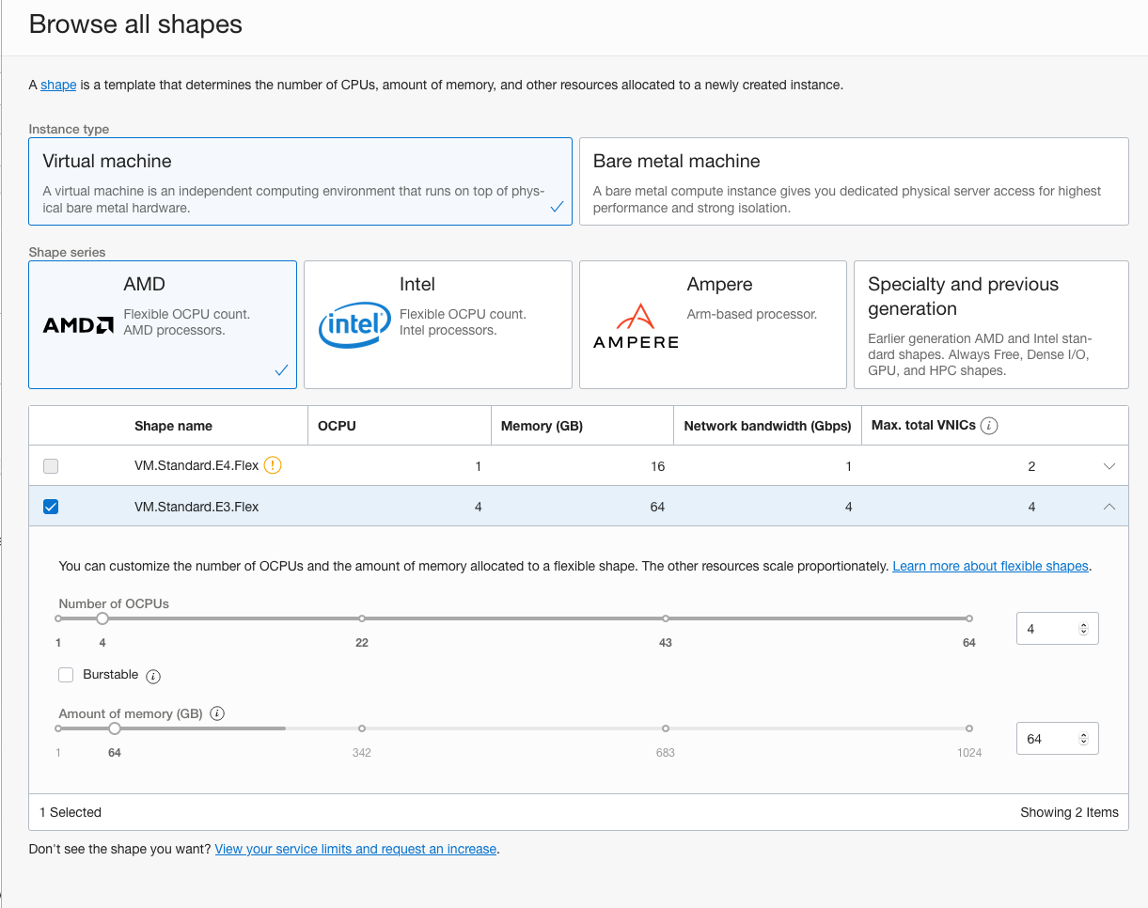

Download the private key

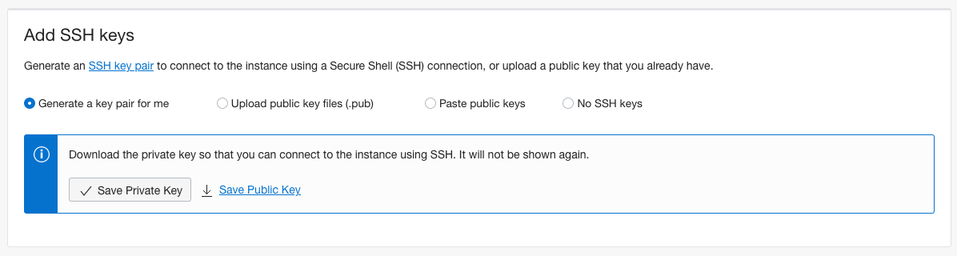

We’ll leave the boot volume as it is because we will create a data block volume later

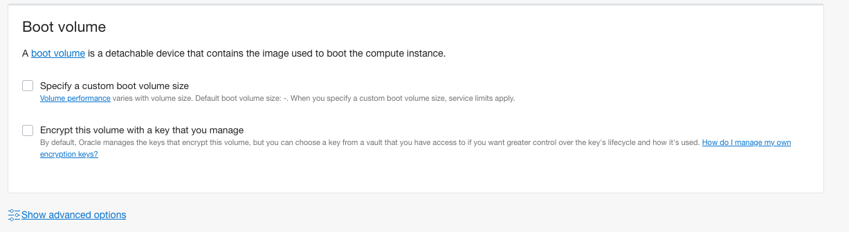

Provisioning



Ready to Connect

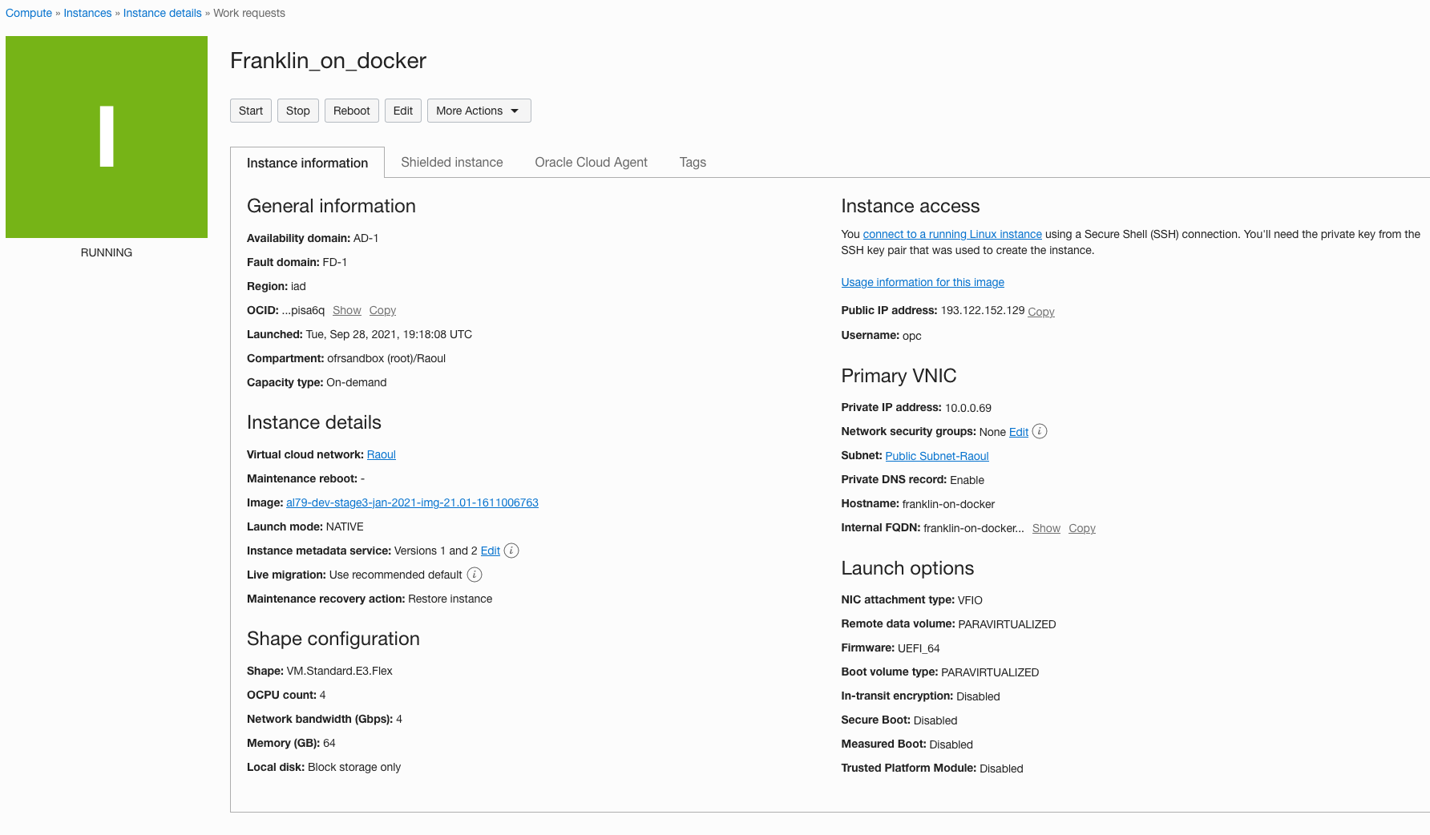

Add a data block volume

Go to block volume create page

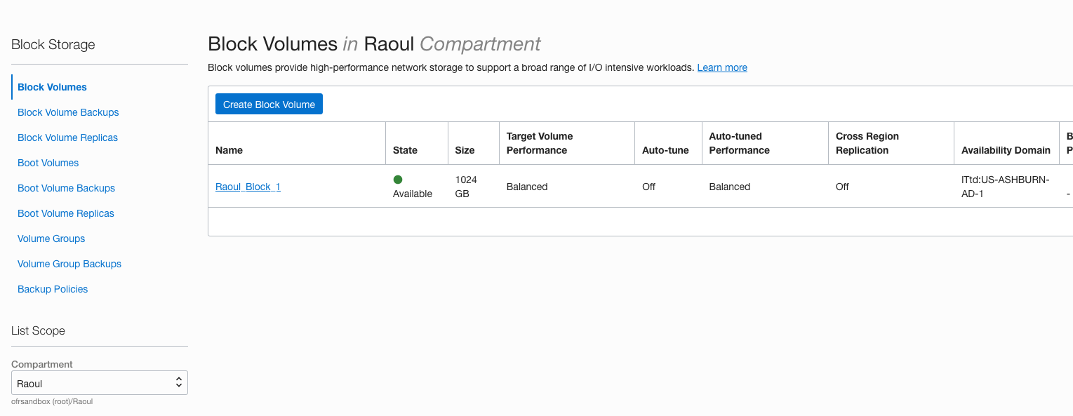

Make sure it’s in the same AD

Made it 1 TB for now – try and overestimate what you need, you are only charged for what you use and resizing is a pain

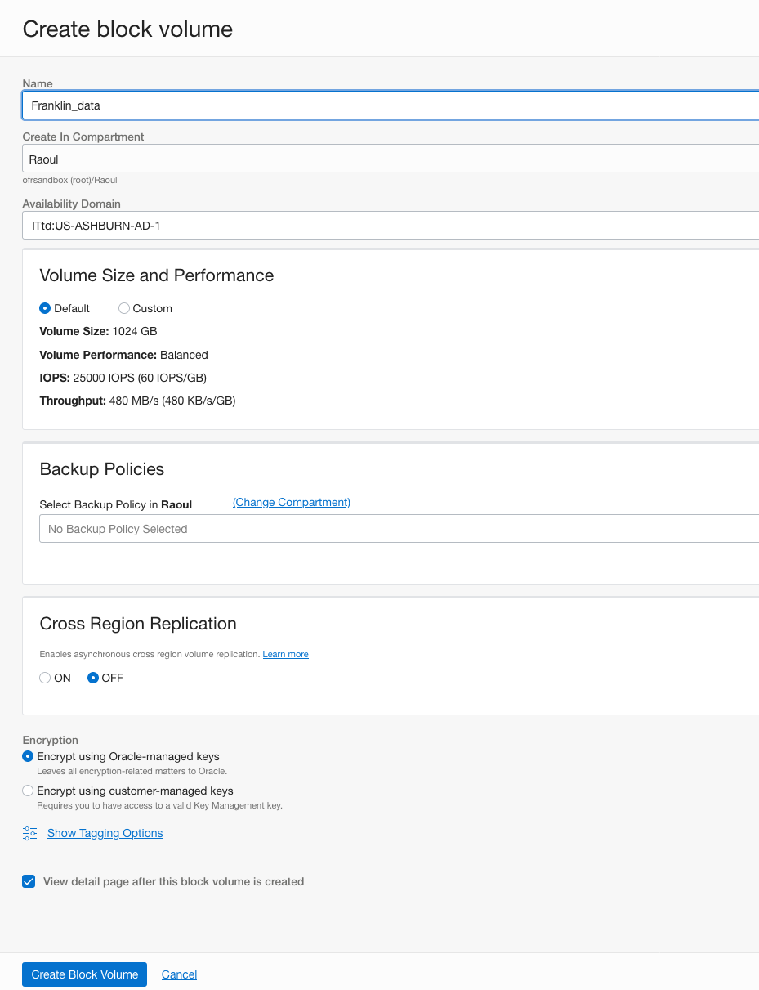

Provisioned too quickly for me to get a screen shot of in-progress



Before we mount and format, let’s set up SSH connection to server

I’m on the mac and I like to store credentials to simplify console access – but you can just use commands in terminal as well if you like

If you are on windows you can do the same with putty – and it’s easier to configure tunneling (see later on) and SCP when you set up SSH this way



Don’t forget to change the permissions on the private key



Now you can connect just using ssh <servername> rather than

ssh -i <private key file> <username>@<ip address>

# Installing Franklin on the server

Docker is already installed on the oracle cloud developer image

Check this by running docker help

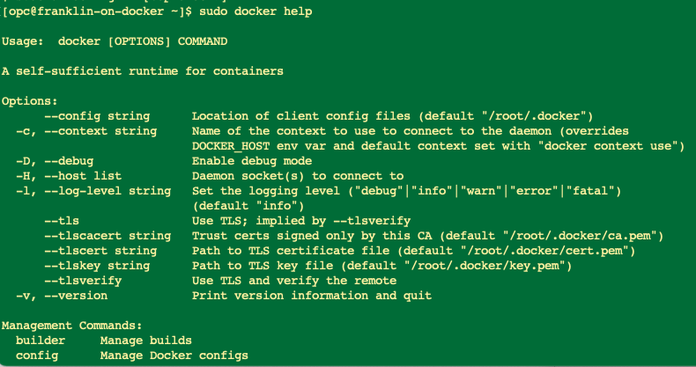

First problem we encounter is that the franklin image is hard to find – it’s not on the azavea or agroimpacts github repos.

BUT, we can search in the docker repository and fortunately with a little detective work we know the correct image is in jisantuc/franklin on docker.io

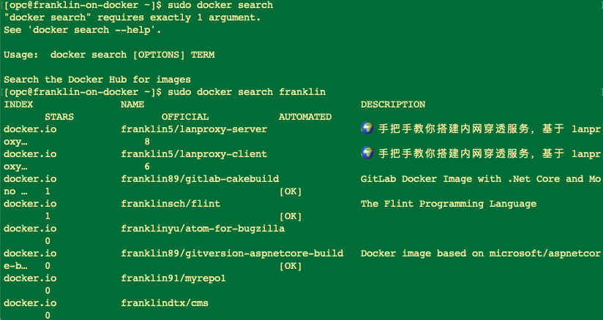

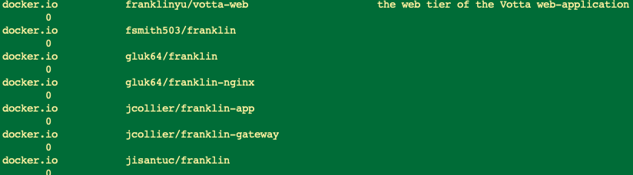

So now we go and grab that docker image



And now if we run docker images we can see the Franklin container image

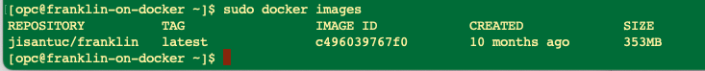

We need a PostGIS instance too, so let’s search for that and download it too

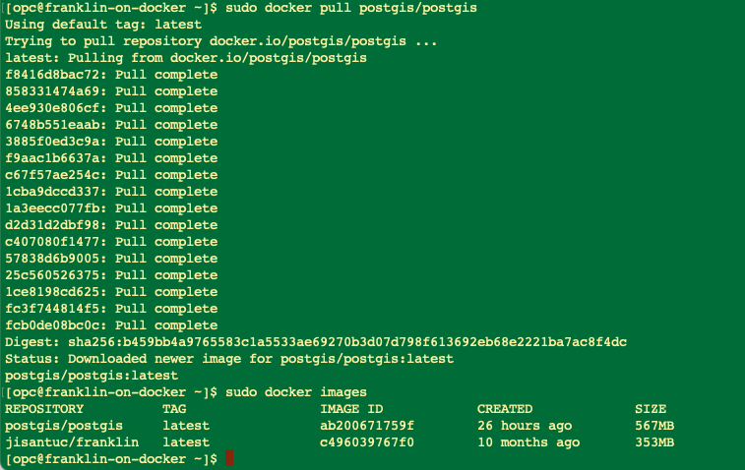

Follow the instructions

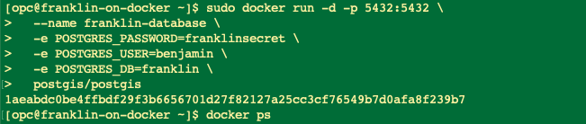



Now you can run the migration as in the instructions

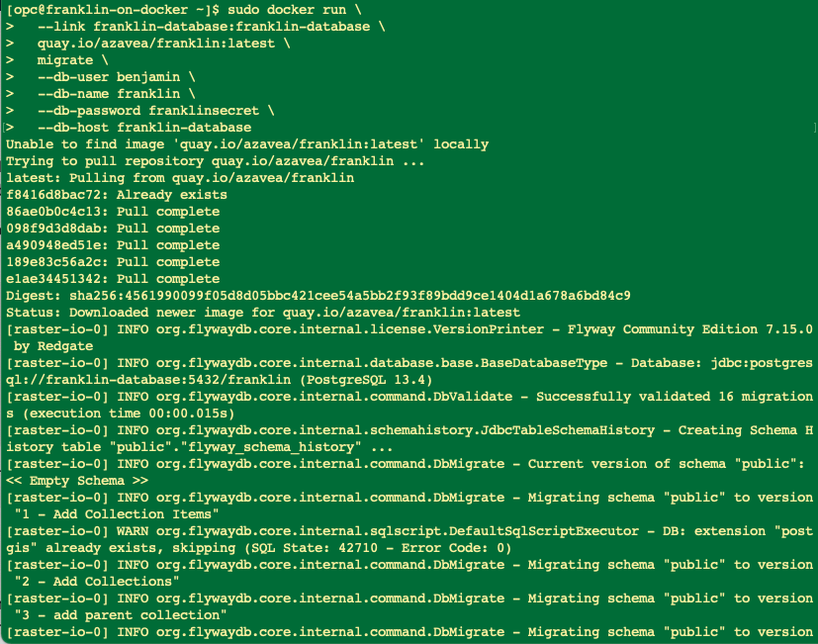

Now we need to import data and to do that we need to go and set up the storage connections

# Configuring Storage

## Block volume

We created a block volume called Franklin_data earlier in this process

Now we need to mount it onto the virtual machine we have been working with

Navigate to the compute instance on the OCI dashboard and then scroll down on the instance details

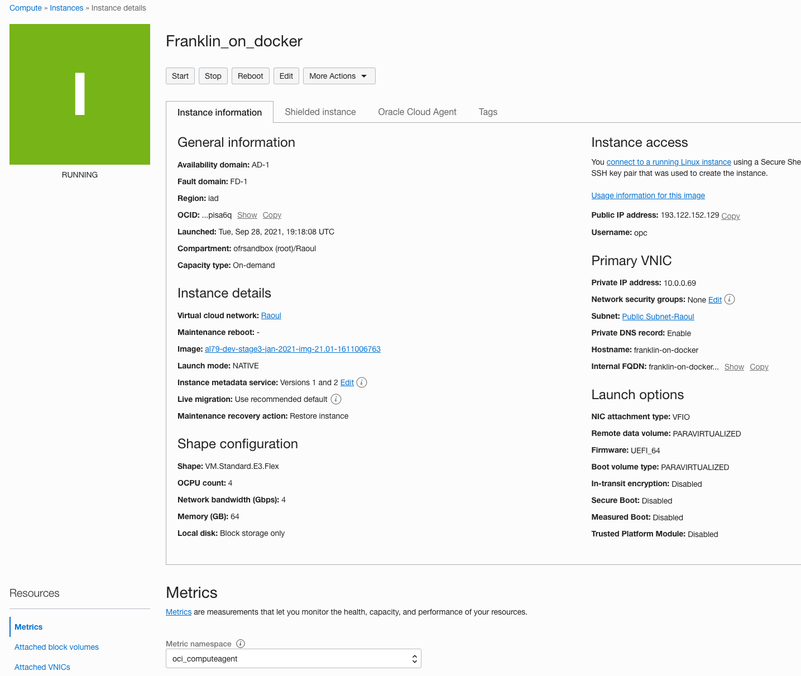

You can see there are no block volumes currently attached

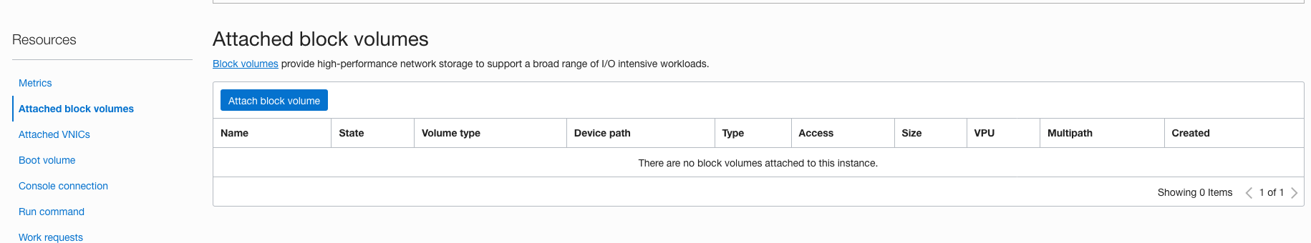

So we attach the block volume we created to the compute image

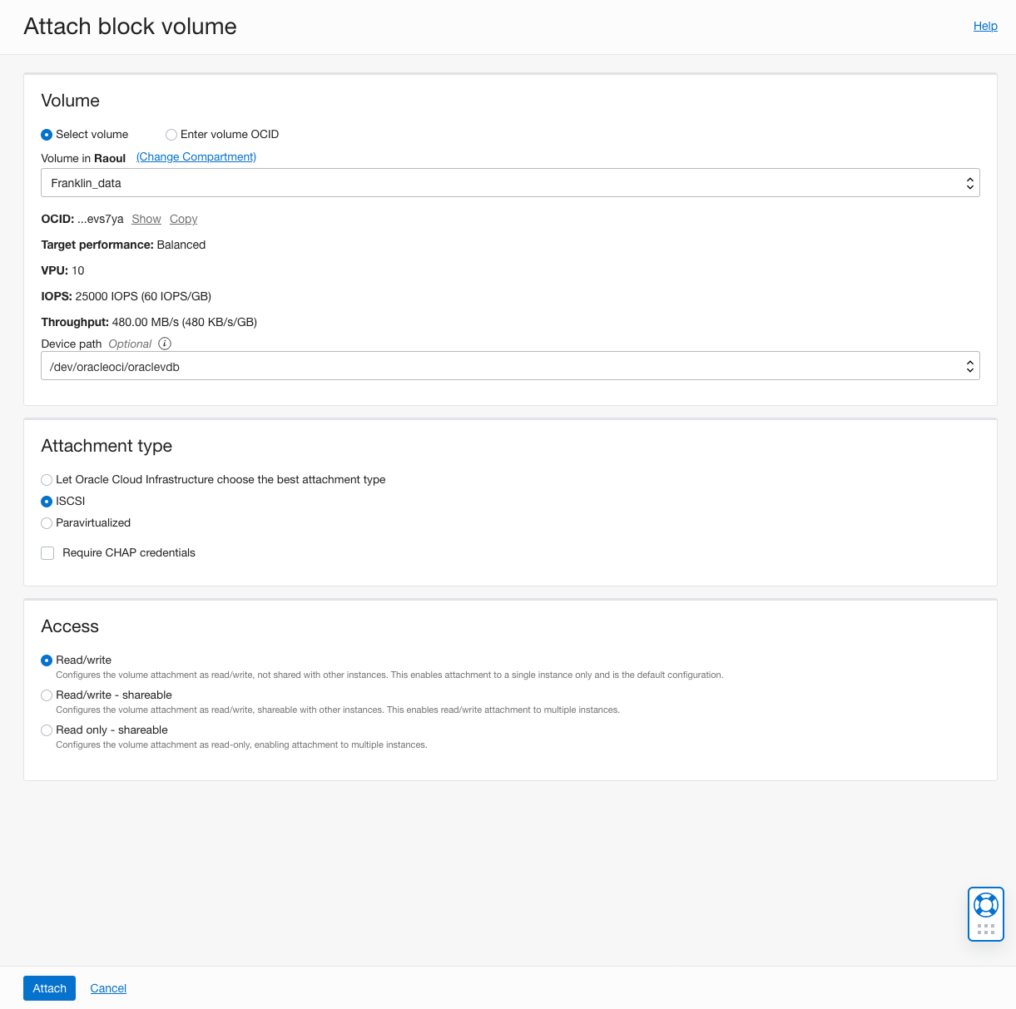

Some things to note:

You don’t have to specify a device path but life is easier if you do

We recommend choosing ISCSI as an attachment type rather than leaving it as paravirtualized

CHAP credentials do add security, but they also add complexity. Unless you have PII or PHI on the volume you can leave them off

Success message

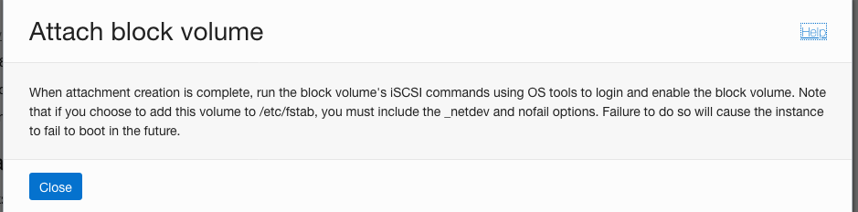

Now click on the three dots to the extreme right of the attached volume listing



Select the ISCSI commands and information option and you will get this screen

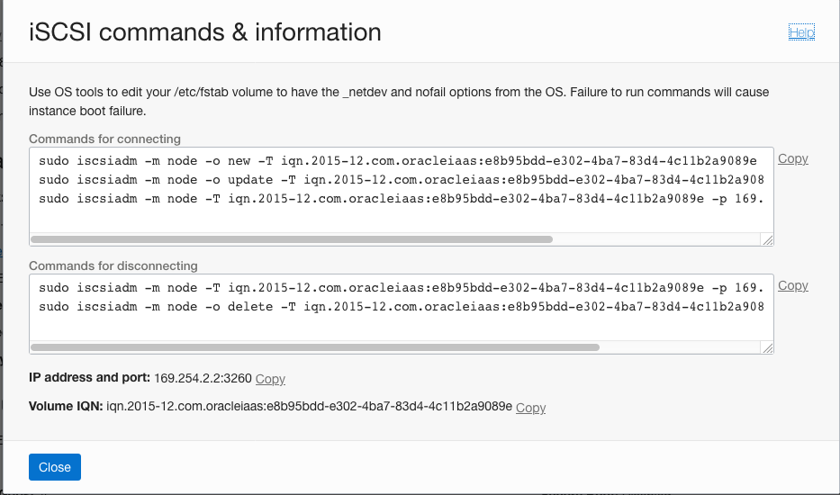

Copy each of the commands (line by line is better) and execute



Fdisk -l will show the new drive mounted

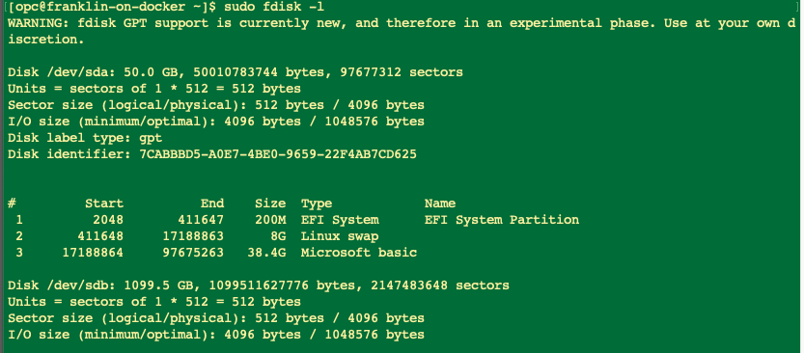

Next we need to format the volume. I chose xfs as the filesystem, but you could also choose ext4 or another fs if you prefer.

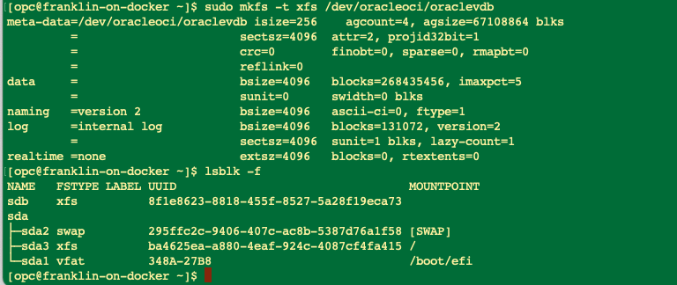

Now we need to create a mount point and mount the partition to it

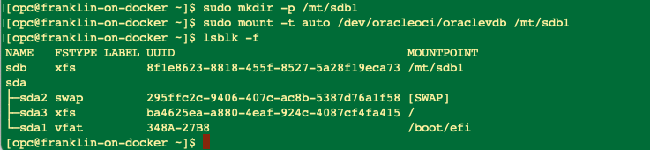

Now we have a place to house our data seperate from the OS and applications

# Create Object Storage and Connect it

Create a bucket

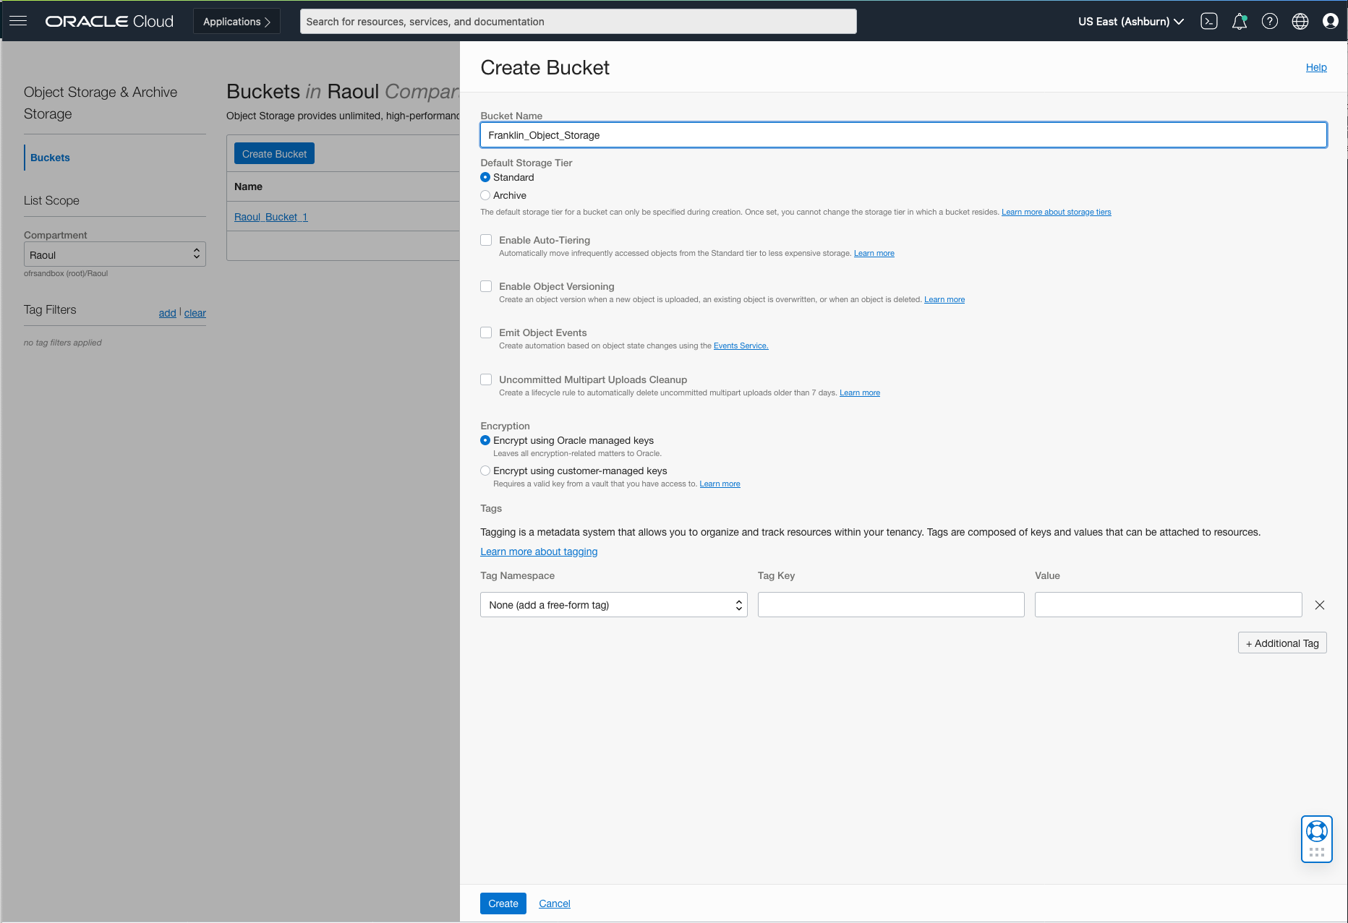

Create a policy to allow access

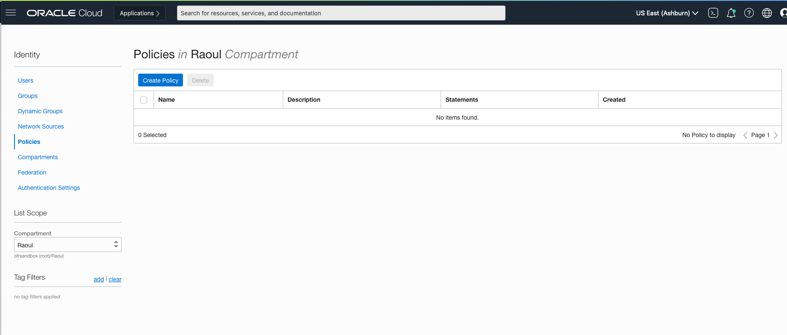

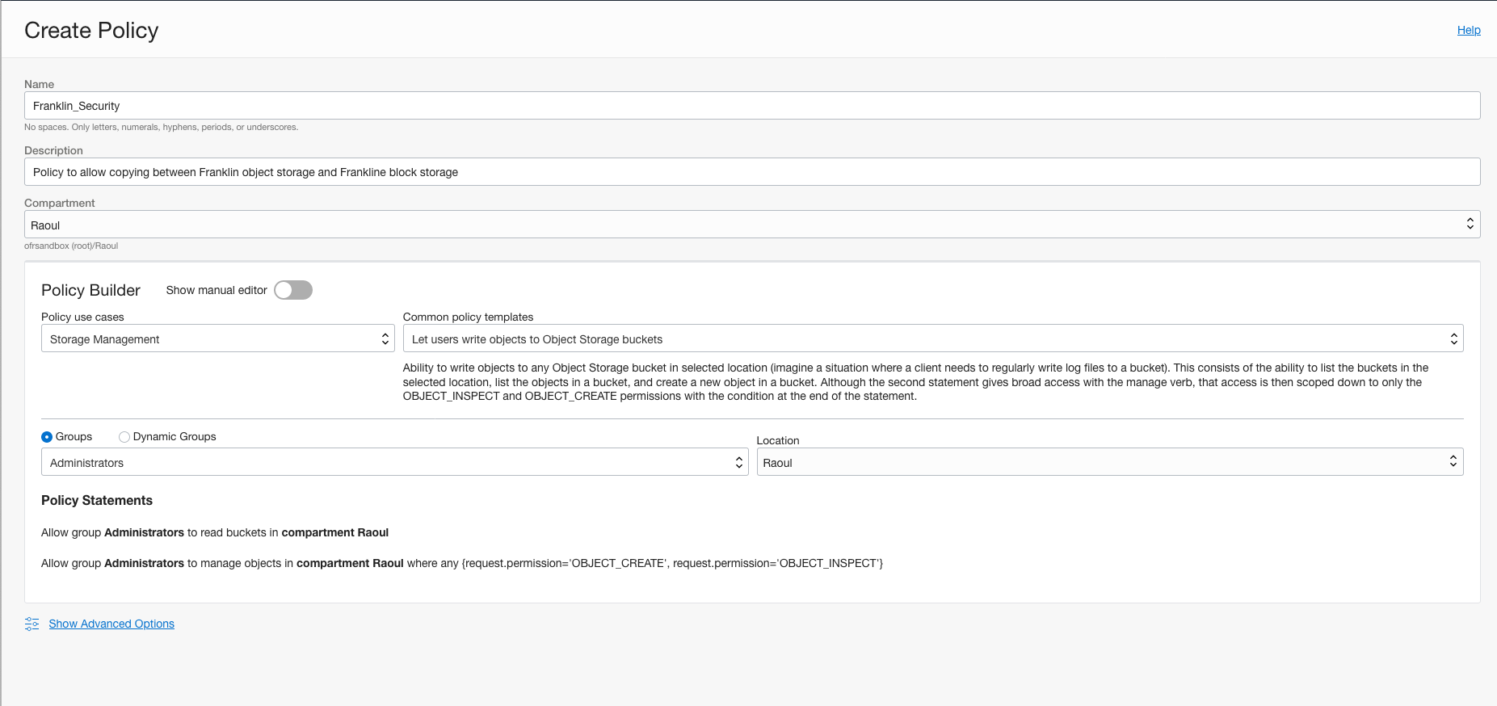

Edit the policy to allow admins to be able to manage buckets as well as objects

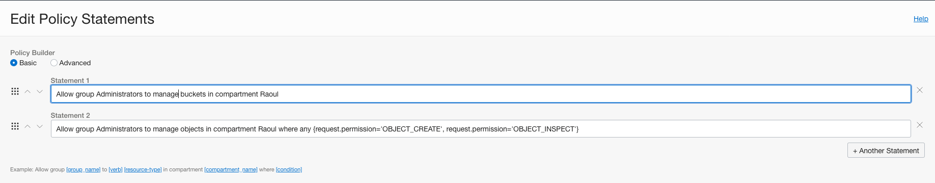

Create API Key from user profile

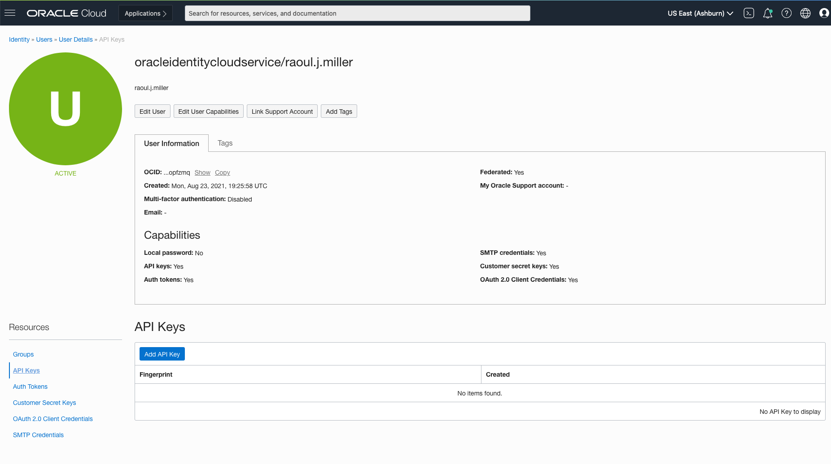

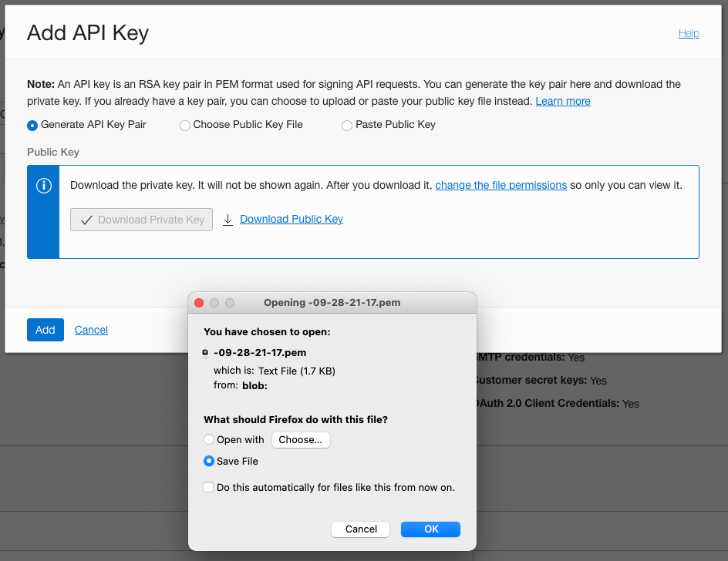

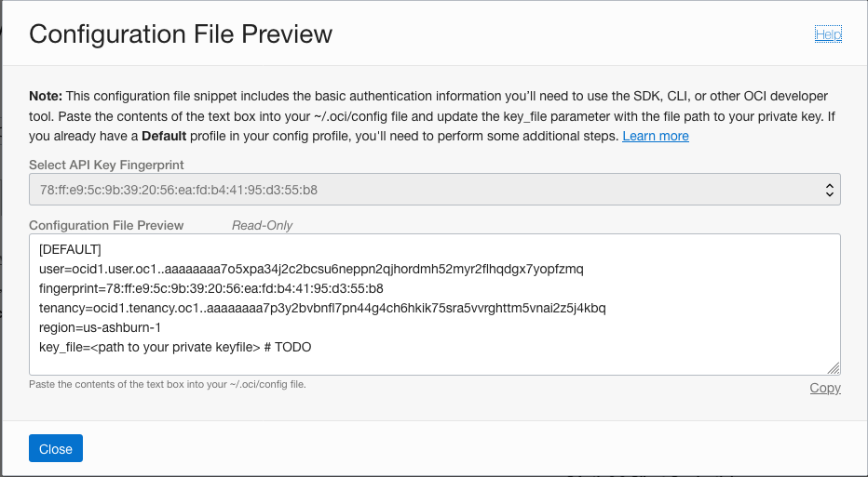

WE need to copy this config (and the private key file) to the remote server

Create an .oci directory under /home/opc

Sudo mkdir .oci

Create a config text file

Sudo vi config

Copy the text from the configuration file preview into that file – we will need to change the path once we have uploaded the private API key to the server

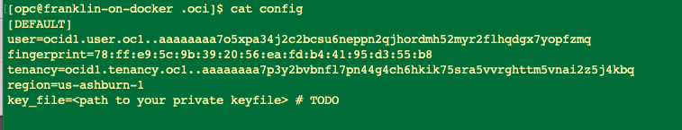

Log out of the remote server, copy the API key file to the home directory, then sudo copy the file to wherever you want to store it.

NOTE – because I have setup SSH on my mac to use a connection string I can just invoke scp <name> rather than scp -i <key path> <username>@<ip address> …….

(you need to copy in two steps because the data drive is owned by root and you are remoting in as opc)

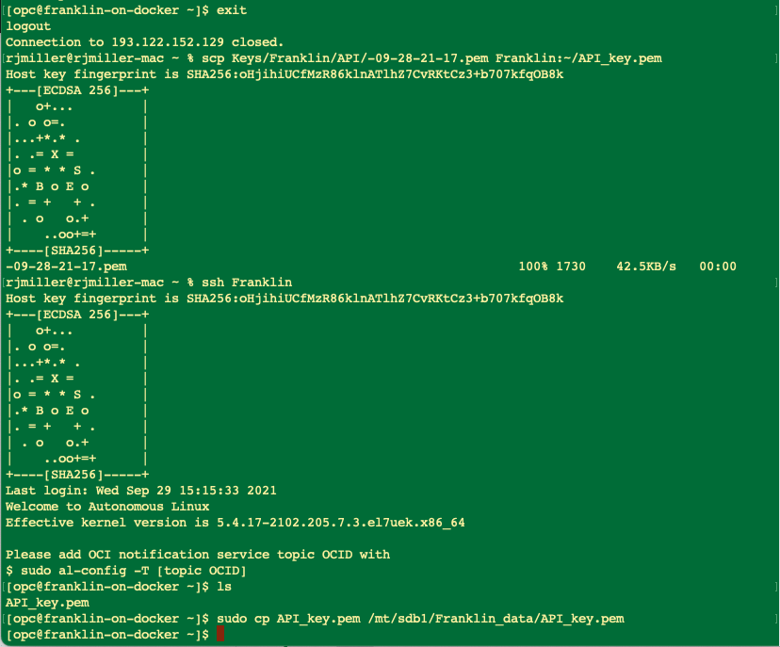

Edit the config file at /home/opc/.oci to reflect the location of the api key

NOTE – I created a folder called Keys on the data drive and put the API key in there to make the file storage neater

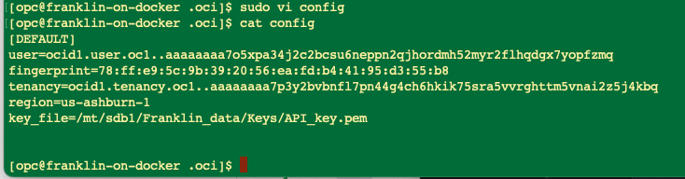

Upload some sample files to object storage to test the connectivity

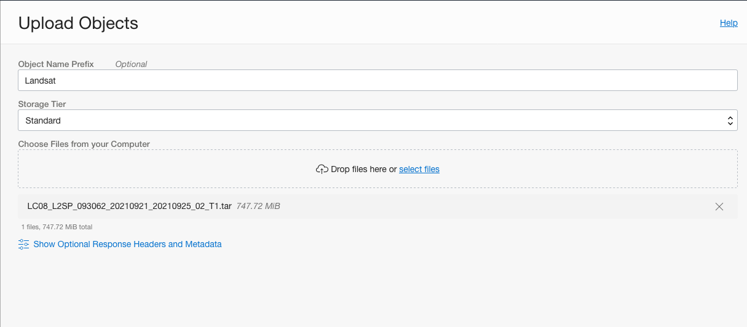



Now go back to the compute node and see if we can copy files from object storage buckets to block storage

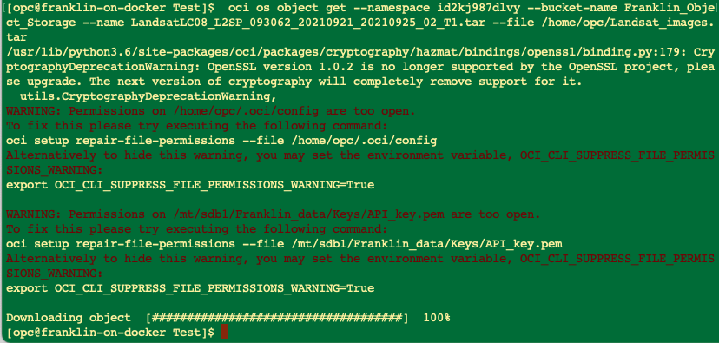

Success! With a couple of warnings

Let’s fix those warnings while we are here:

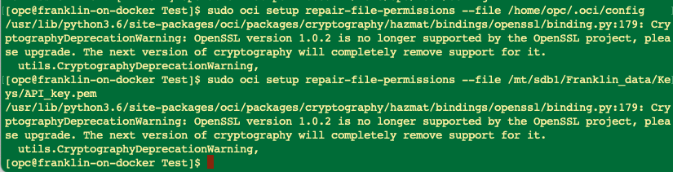

Move the images to the Franklin data store and untar the tarball

